The Mountain Game

Objective: The student will gain speed and accuracy in reading sight words.
Materials:
- One mountain game board for each player.
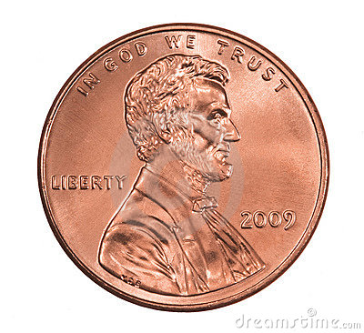
- A chip/game piece for each player
(you can use anything- a penny, a bean…etc)

- Flashcards with sight words.

How to play:
- Players place game pieces on START on their game boards.

- One player (the adult) shows a sight word to the player(s).

- If the word is the same as the word in the first box on a game board, that player moves their game piece into that box. You cannot skip words- they must be done in order.
If the word isn’t the same, keep showing cards until a match is made.

- Continue until a player reaches the END, or the TOP of the mountain!

